
Farmers 1102 Broadway
National Emmetsburg IA, 50536
Company (712)852-2002

FOR SALE
1901 19th Street
Emmetsburg, Iowa 50536
$189,900.00

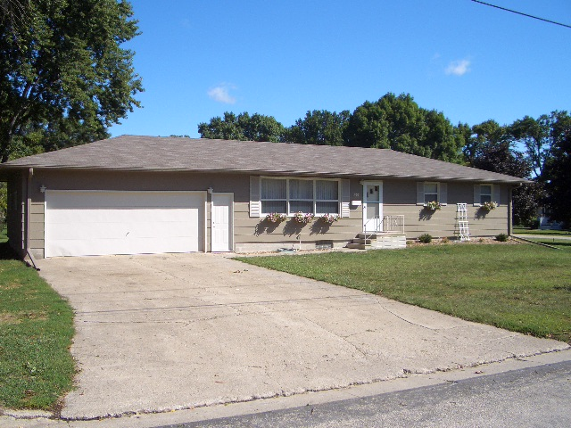

Bedrooms  3 | Square Footage  1,344 sq ft | Garage Size  672 sf / 24’ x 28’ | Description  Come take a look at this completely renovated ranch home. All new kitchen cabinets and flooring throughout the home. Large basement family room with separate entrance from the garage. New roof in summer of 2011, all new wiring for all electric utilities.
Bathrooms  1 plus | House size  48’ x 88’ | Central  Air Conditioning
Year Built  1975 | Lot Size  132’ x 132’ | Electric  Heat
Full Basement / Standard Finish
Taxes  $1,386 |  | Average Electric  $96.00

Farmers National Company
Mike Wentzel, Broker
Jack Nolan, Sales Associate
1102 Broadway
Kermore Building
Emmetsburg, Iowa 50536

All information is believed to be accurate, but is not guaranteed by the listed agent or broker.

