
Farmers 1102 Broadway
National Emmetsburg IA, 50536
Company (712)852-2002

FOR SALE
208 State Street
Emmetsburg, Iowa 50536
$94,900.00
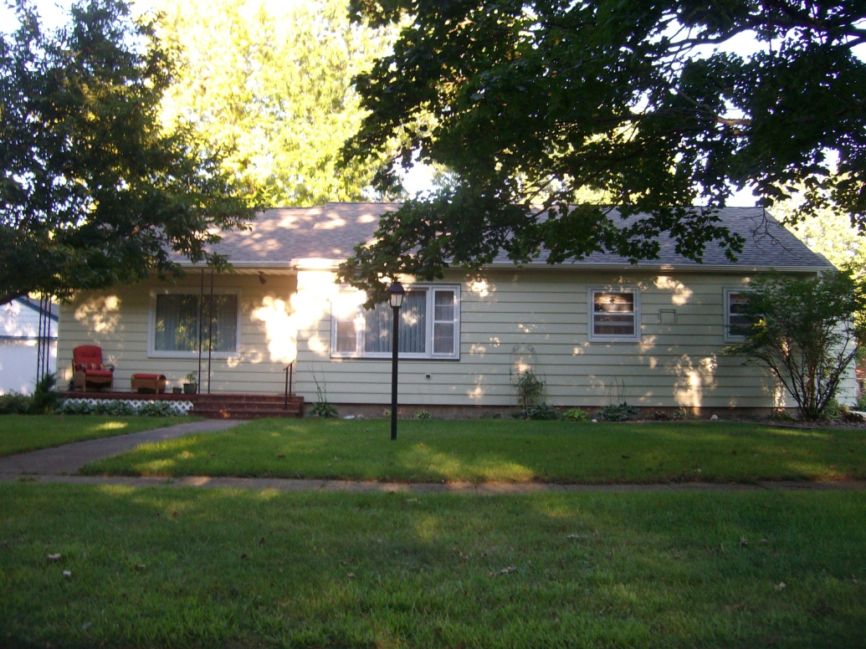
Bedrooms  3 | Square Footage  1,320 sq ft. | Garage Size (detached)  26’ x 25’ | Description  This ranch style home is located close to the High School. Recent improvements include new roof, new paint, new furnace, new bathroom, new floor in the kitchen and much more. Call today to look.
Bathrooms  1 ¾ | House size  28’ x 52’ | Air Conditioning  Central
Year Built  1953 | Lot Size  66’ x 122’ | Heat  Nat Gas FA
Taxes  $1,178 | Average Gas  $63.28 | Average Electric  $86.00

Farmers National Company
Mike Wentzel, Broker
Jack Nolan, Sales Associate
1102 Broadway
Kermore Building
Emmetsburg, Iowa 50536

All information is believed to be accurate, but is not guaranteed by the listed agent or broker.

